A Novel Approach to Low Cost User Friendly Brain Stimulator

Donghyun (David) Seo, Carim-Sanni Sobur, Eric Luu, Radhanath Purakait, Shalih Miah

Final Report

BME 4600: Biomedical Engineering Senior Design

Sponsor: Dr. Marom Bikson

Faculty Mentor: Professor Alessandra Carriero

TA: Jack Twiddy, Evan Azoulay

**Abstract**

The goal of this project is to create a low cost and user friendly tDCS device that will require minimum setup. The target audience for this device are consumers who are interested in using the tDCS device to enhance their memorization and learning capability. The design of the device was split into three components, headgear, electrode and circuitry. The headgear design with the best ergonomics was the cap headgear and the electrode design with the best current distribution was the sponge electrode. The circuit design is able to be powered with 9V batteries, outputs a constant current between 1~2 mA, includes a contact safety mechanism and has a ramp up and down feature at the beginning and end of the stimulation.

**Background**

Transcranial direct current stimulation (tDCS) is a form of neurostimulation where low levels of constant current is applied to certain areas of the brain. The brain is comprised of a complex network of nerve cells also known as neurons. Neurons are responsible for processing and transmitting signals throughout the brain. Neurons communicate by sending small electrical, and chemical impulses called synapses through the cell body with the help of neurotransmitters. Electrical synapses, unlike chemical synapses, conduct nerve impulses faster (approximately 10 times faster), causing information to pass from neuron to neuron more quickly [13]. The process of polarization and depolarization of the cell bodies and the synaptic connections can be modulated with direct current (DC). An anodal stimulation (negative voltage) will tend to produce more frequent neuronal firing and increase plasticity due to hyperpolarization of neurons, cathodal stimulation will similarly create the opposite physiological effect [14]. However, it is not clear how this physiological response relates to changes in mood and behavior as the full link has not been established [14].

The tDCS works by sending a one directional current through electrodes attached to the scalp. The placement of the electrodes in the head are called montages and different montage can be used for different treatments such as enhancing attention span, memorization, problem-solving, depression and anxiety. Depending on where and how the electrodes are placed can change the direction of the current and which area of the brain are being affected. The low current coming from tDCS device can alter a neuron's activity in a desired direction. This means that tDCS can strengthen or weaken the signals between neurons also known as synaptic plasticity [15]. Synaptic plasticity is linked to memory, ability to learn, and how well neurons communicate. A person with mental disorders have their neuron activity decreased compared to that of a normal person.​ Therefore, enhancing synaptic plasticity has the potential to enhance neuronal communication.

A tDCS device consists of an electrical circuit, a pair or more electrodes, and potentially some headgear to place electrodes properly. In order to apply DC to the brain the current must be generated at the circuit. This circuit provides a flow of electrons from the negatively charged electrode to the positively charged electrode. Sometimes manufactures may include additionally waveforms. The device includes a battery and potentially some safety and regulative circuitry. Regulatory circuitry may modulate the voltage applied to the skin to maintain safe current limits. Critically there must be some measure of dosage that the circuit maintains. Dosage is understood as the current (Amperes) level and time of treatment (seconds).

The tDCS was mainly developed to help patients that have experienced brain injuries. However, studies have shown that tDCS can also be used on healthy people to stimuli parts of their brain to increase their cognitive performance. As mentioned before, depending on what area of the brain is being stimulated studies have shown that tDCS has the capability to enhance a person’s attention span, coordination, memory, and problem-solving ability. People with occupations such as high school/college students, teacher, military personnels, pilots, policemen, watchmen, or anyone with job the requires enhanced focus and memorization can benefit from tDCS.

One of the biggest problems with tDCS device is that its very costly and hard to use for people who are not familiar with the device. The current cost of tDCS devices in the markets ranges from $80 to $5000. This hinders the accessibility of tDCS for people who are interested in the treatment or just wants to try it for the first time to see how they feel about the device. Our group tackled this problem by attempting to create a low cost tDCS device with a concentration montage for enhancing memorization and learning.

**Need Statement:** Develop a low cost tDCS device that will output a constant current of 2 mA for a duration of 20 ~ 45 minutes.

**Prior Art​**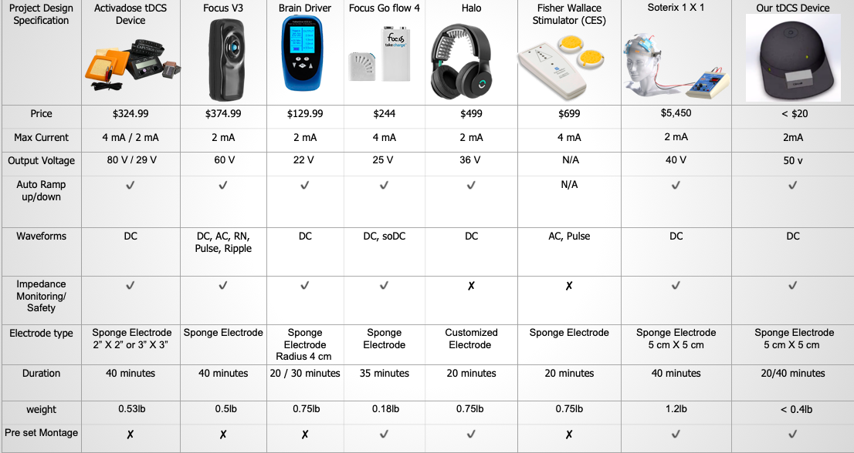

**Table 1:** This table shows prior art comparison to our project design specification**.**

To expedite the conceptual design process, currently available tDCS devices were reviewed and compared to our target list of specifications. During our comparison in Table 1, we found only Soterix 1X1 fit most of our project specification. One issue we noticed is that the Soterix 1X1 is a bit heavier and relatively expensive. An extensive patent search was performed in order to seek information about or related to existing tDCS devices. For a more detailed analysis, the group also considered widely available DIY tDCS devices. Since the goal is to create a low-cost device with similar feature as the one on market, the team chose to employ idea from both Soterix 1X1 and go flow with a cheaper approach. Compared to other device in Table 1our device cost less than 10% most approved tDCS device. Our device also exceed expectation as it has a ramp up/down, impedance monitoring feature and pre-set montage unlike most tDCS devices.

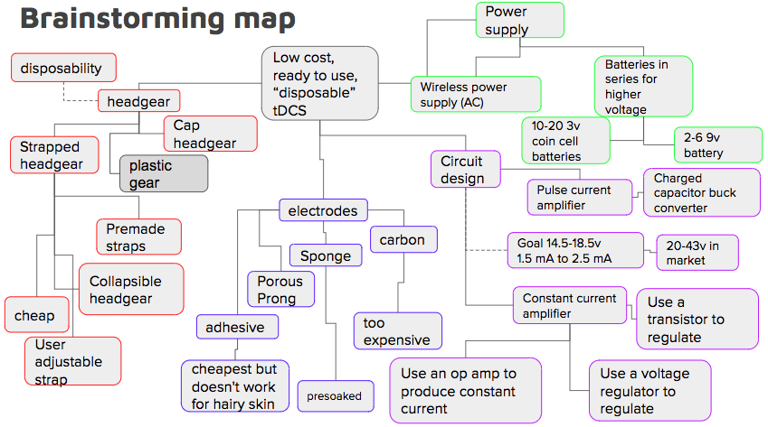

**Figure 1:** This shows our brainstorming and concept map from previous semester

In brainstorming our project, we essentially had 4 main parts we branched from, the cap, the power supply, the electrodes and the circuit design. For each of these branches we came up with different approaches and options in the components of our device, we later discerned what Ideas were most appropriate based on our sponsor specifications and what we realized were most optimal based on our decision matrix.

**Design selection process**

**Design Concepts**

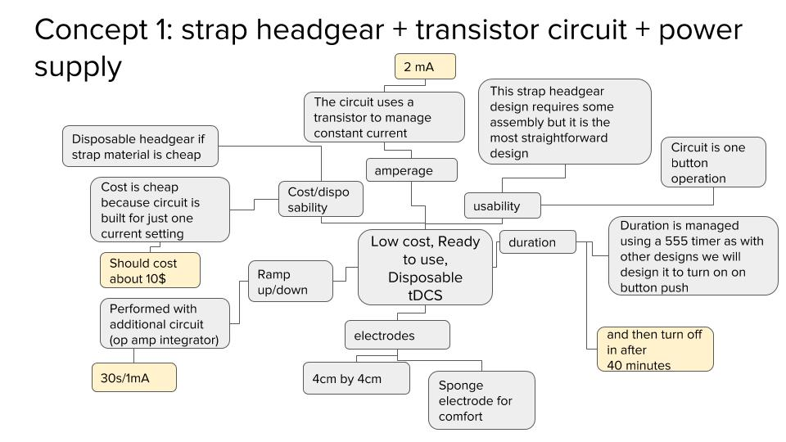

**Figure 2**: This is Concept number 1 of our design concept from previous semester

In this design a strapped headgear design with a circuit built using a single transistor and some passive components. This will lower the cost of the product. This design will also include a 555 timer to control dosage in terms of time. This design shows promising feasibility in the hat 555 circuit is well used in the DIY and professional community. This circuit is also unique in that it proposes a headgear that uses snap together straps. The electrodes are not presoaked

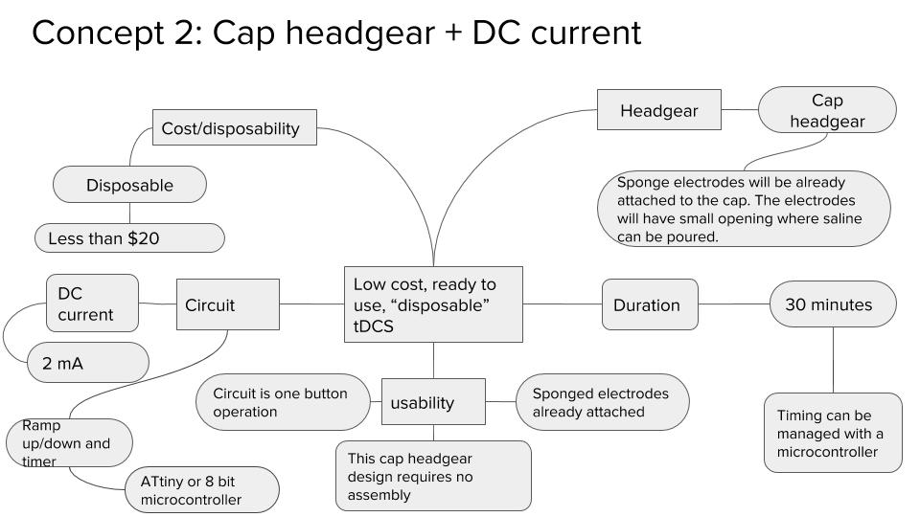

**Figure 3:** This is Concept number 2 of our design concept from previous semester

This design concept comprises of a hat with embedded tDCS device and electrode. The device should cost rounds up to about $20. The design has no to little preparation process. User is able to use this device by removing the adhesive patching from the surface of the sponge, putting the hat on and start the stimulation.

The hat will be adjustable between 55 to 59 cm circumference. Sponge electrode will be pre-attached to the hat, with small opening for users to apply saline before stimulation. Constant voltage system in the circuit allows the device to operate continuously regardless of battery health. After 30 minutes of use, the device will slowly ramp down the current and power off the device. The device should be completely disposable after use.

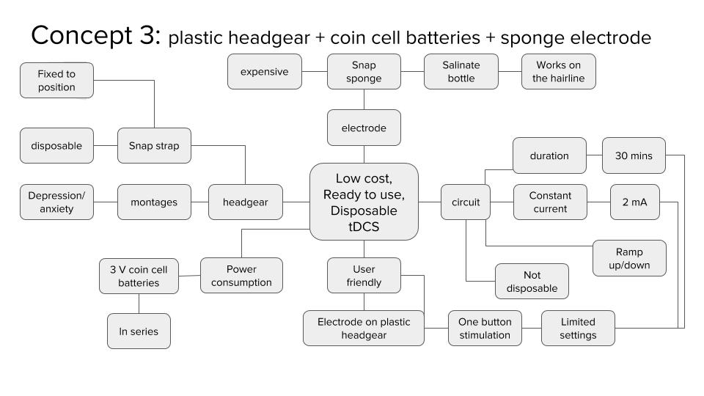

**Figure 4:** This is Concept number 3 of our design concept from previous semester

This concept is partially disposable design. The rigid plastic headgear (https://www.youtube.com/watch?v=LBYsY2arOrc) and the sponge electrodes are disposable, and the circuit and the 3V coin cell batteries are reusable. The headgear is affixed to the head with the spring tension of the headgear itself where the pressure of the headgear allows it to stimulate specific montage of depression and anxiety, though it should also be able to handle the concentration montage easily. The electrodes are pre soaked with saline which allows them to conduct current through the hairline. The circuit is preset to stimulate in 2 mA current for 30 minutes with ramp up and down to avoid possible shocking.

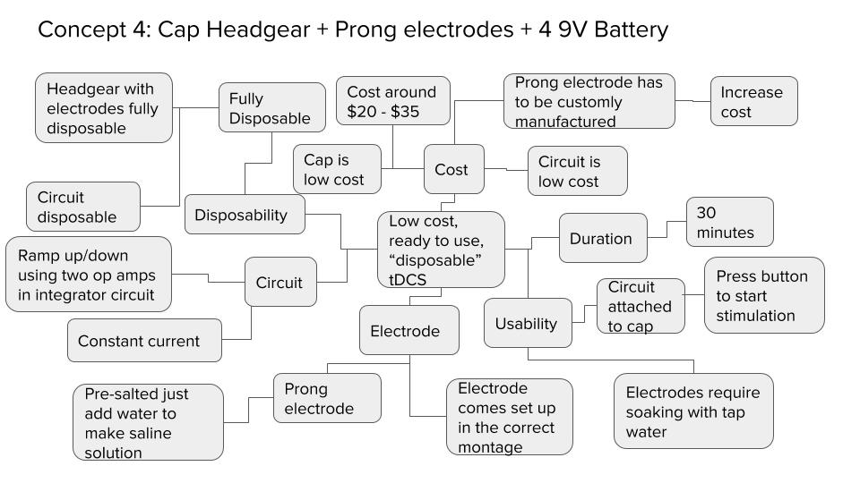

**Figure 5:** This is Concept number 4 of our design concept from previous semester

In this design prong electrodes are utilized, similar to the ones in the background. The prong electrode comes attached at the correct montage to the inside of the cap. The electrode is presalted and activated by applying tap water. The circuit comes in a separate container that is attachable via snap to the cap. The circuit is powered by 4 9V batteries that produces a steady current with a ramp up/down feature using two op amps. The cap, electrode, and circuit is fully disposable.

**Concept selection matrix**

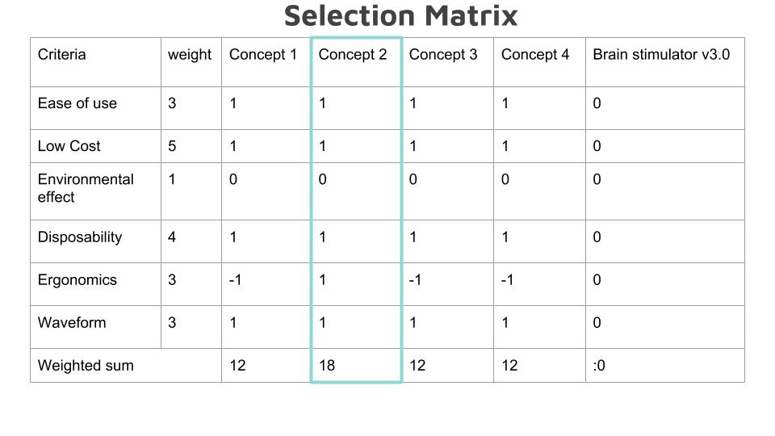

**Table 2:** This shows the concept that we chose at the end of our previous semester.

Concept 2 which includes a cap and a constant current power supply design was selected because we found it more ergonomic when compared to similar designs using a strap headgear. Concept 2 and concept 4 are quite similar however for concept 4 we chose a -1 for ergonomics. The reason being is that the prong electrodes create a concentrated current loading on the point sources from the prongs that make contact with the scalp. This causes discomfort in terms of a slight tingling/stinging sensation. The sponge electrode is preferred, in concept 2, over the prong electrode.

**Mockup Prototype​**

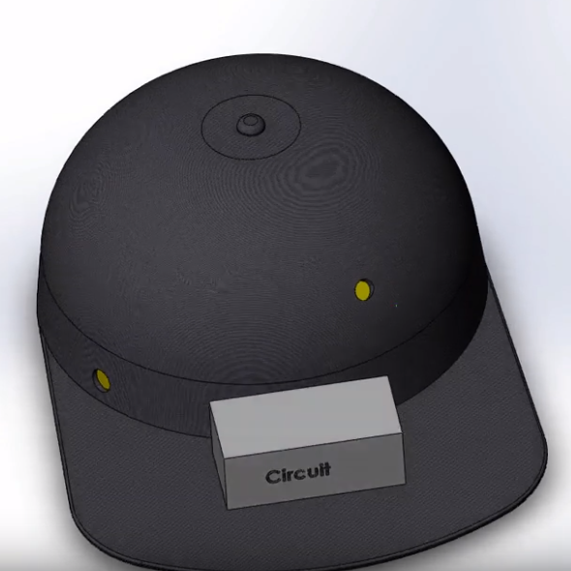

**Figure 6:** This is the mockup prototype that we designed at the end of fall 2018 semester using a computer tool called Computer-aided design (CAD). A 3D version of this hat can be seen in <https://www.youtube.com/watch?v=UW1DnpEKiNs>.

This prototype was made based on Concept 2. The hat come with 2 electrodes attached at the position F3 and FP2 which is the Depression and Anxiety montage.​ Wires are attached to the conductive snap on pins.​ Carbon rubber snap electrodes inside the sponges are attached to the conductive snap on pins.​ Circuit box is placed on the brim of the hat and connected to the wires that are attached to the 2 electrodes.​ Small opening are made on the outside of the hat where the electrode are placed where saline can be injected or poured.

**Progress of the device in BME 460**

Throughout senior design we have approached many problems and developed solutions in the process of executing out the project design specification for our tDCS device. The design specification is shown in Table 3. We divided our group into two subgroups, one to work on the circuit, and the other to work on the headgear which also includes the electrodes. This way we can cover more ground and effectively tackle different problems for both circuit and headgear designs. The system block diagram of our device can be found in Figure 7 and shows how the project was divided. For our circuit, we came across many problems such as getting the circuit to produce at least 43V, achieving 1~2 mA of constant current, ramp up/down, safety feature, and reliability of the circuit itself. For the headgear, we had problems with the comfortability/fit of the hat, contact quality of the sponge electrodes, and the hat material.

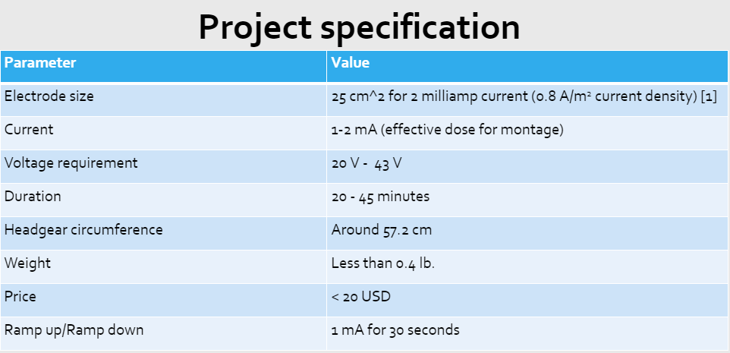

**Table 3 :** This table shows the Project Design Specification for our tDCS device. All the specifications from our previous semester remains the same except the current. The range of the current was 2mA - 4mA [2], according to the research we did that was the usual safety threshold. However, we changed the current range to 1mA - 2mA because that was the range of effective dose for the concentration montage. Also, if we want a higher current than 2mA we would need higher voltage requirement. Highest voltage the circuit can produce is 50V. We managed to accomplish all the product design specifications except for weight which slightly exceeds 0.4 lbs, and the ramp up and ramp down time. Ramp has a tradeoff, 1 milliamp per 30s is possible but it comes at the cost of ramp start precision. In our design process we determined that 1 milliamp per 30s ramp may still be possible wither with more advanced algorithms and development in terms of code, or at the cost of less precise timing.

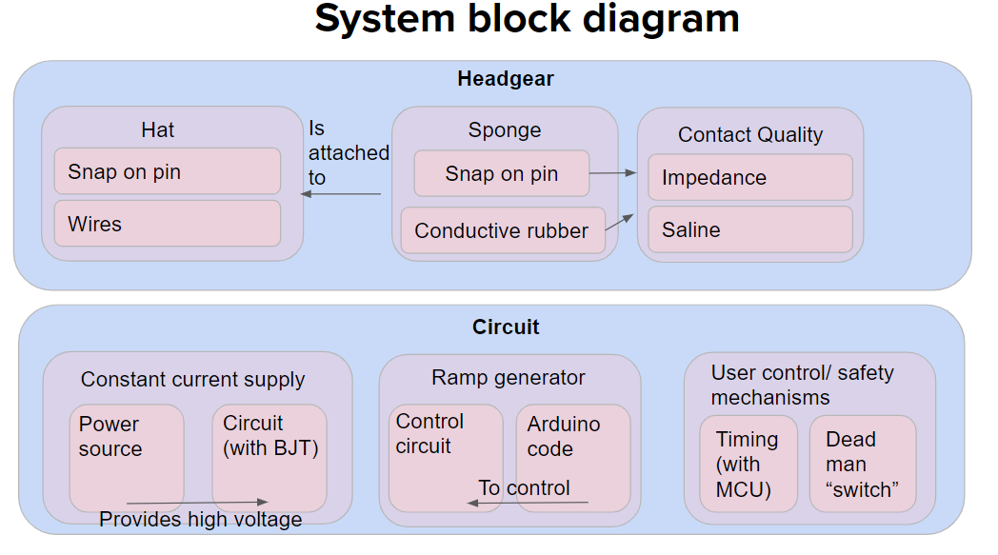

**Figure 7 :** This is the system block diagram for the tDCS hat device. The device was divided into two separate block diagram Headgear and Circuit. For the headgear block diagram there are three components hat, sponge, and the contact quality. For the hat, snap on pins were attached to our desired montage position is FP2 and FP1 which is the concentration montage for enhancing memorization and learning. The sponges also have snap on pins attached to them so they can be snapped on to the hat before stimulation. The wires were also attached to the snap on pins so they can be connected to the multimeter for testing contact quality and connected to the circuit when it's finished. For the circuit block diagram there are three components as well constant current supply, ramp generator, and safety mechanisms. The constant current supply of 2mA is needed for effective dose of the concentration montage. The ramp up and down feature is needed to avoid sudden electric shock when the stimulation starts. The safety mechanisms is needed so that the device recognizes the hat is on the head before allowing the stimulation to start and also turning off the stimulation if its producing too much current than it should.

**Circuit Design Process**

For the first circuit design which is shown in Figure 8 the major hurdle was selecting the right power source. Application program such as NI Multisim was used to simulate circuit design to see if 9V battery would be sufficient enough to give the desire constant current of 2 mA with the head impedance of 20k ohm. Based on the result of the simulations which is shown in Figure 9 the 9V battery was insufficient to output 2 mA of constant current.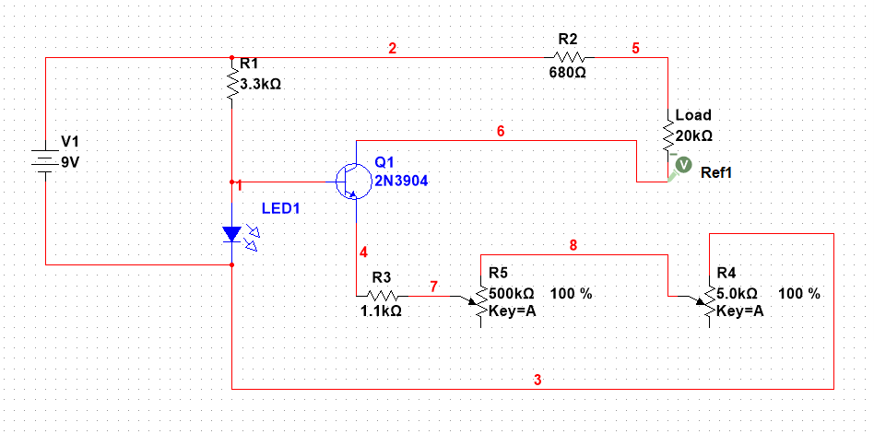

**Figure 8:** The first circuit design also known as BJT tDCS V1 Design 1. This circuit is powered by 9V battery and has bipolar junction transistor (BJT) to control the current.

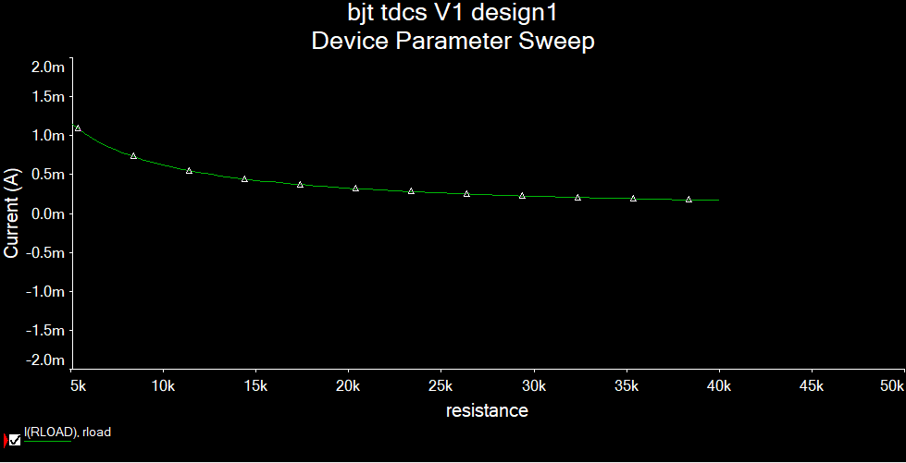

**Figure 9:** This graph shows the current and resistance relationship when the circuit is being powered by 9V battery. At 20k ohm the current is only 0.5 mA.

After making few changes to the first circuit the updated version of the circuit was developed and it’s shown in Figure 10. Using the updated circuit design a simulation of the relationship between voltage and current was created which is shown in Figure 11. From this, it was clear that we needed higher voltage to achieve 2mA of constant current. To solve this problem more 9V batteries was needed however, this will make the circuit bulkier in size. We found another alternative solution where we can use a boost converter to take in low input voltage and output a higher voltage.

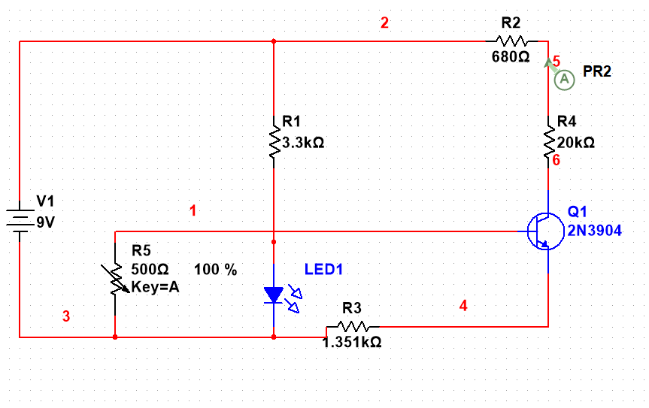

**Figure 10:** This is BJT tDCS V2 design 2. The resistor (R) 3,4,5 was replaced by a single resistor R3 and R5 (potentiometer) was added to the base of the BJT.

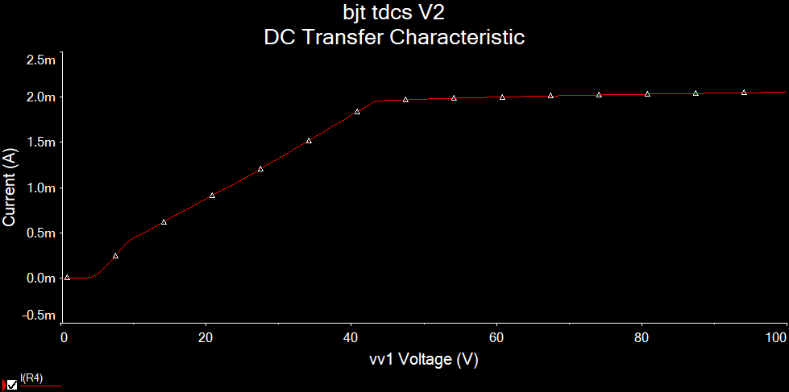

**Figure 11:** This graph shows the relationship between current and voltage. As the voltage increases so the current.

In order for circuit to work properly we needed a appropriate boost converter to step up the voltage from a 9V battery to the 50V which is required for the operation of our constant current circuit. We tried few different boost converter with our circuit and the first was MT3608 based boost converter which is shown in Figure 12. This boost converter had critical issues in providing both the correct voltage as well as being unreliable in general.

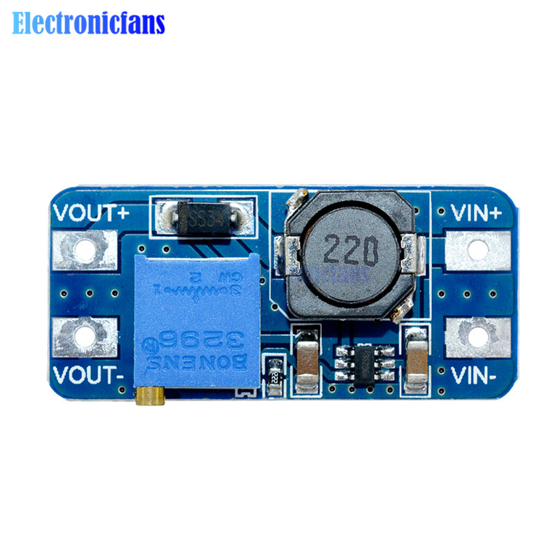

**Figure 12:** MT3608 boost converter [7]. This boost converter was not effective in raising the voltage. Most of the time it did not respond to the circuit and voltage output was less than 30V.

Next, we tried a design that used the XL6009E1 boost converter chip which is shown in Figure 13. When we first tried XL6009E1 it did not work but upon further testing we obtained 50V output. In another board we tried using a different XL6009E1 design which is shown in Figure 14. This XL6009E1 was cheaper and operated at a lower voltage (40V). Our final solution could use the 50V X6009E1 board, however, it is possible to design a cheaper boost converter using bare components instead of an off the shelf component. This could be part of a all in PCB which would include our constant current circuit.

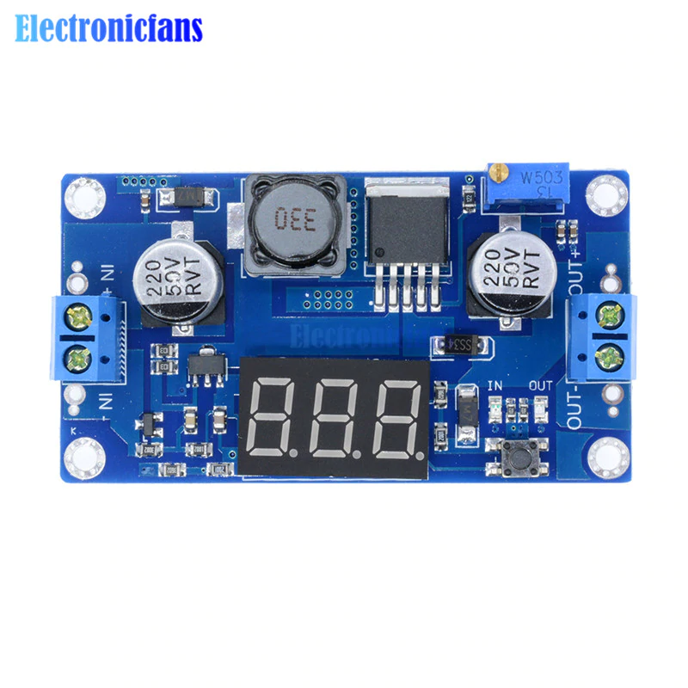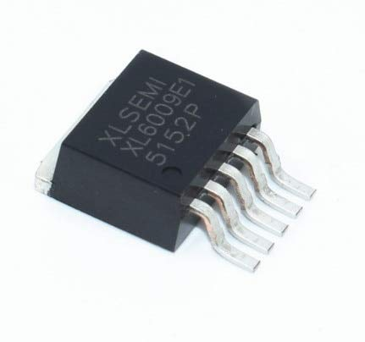

**Figure 13:** XL6009E1 50V boost converter [8]. This boost converter board has XL6009E1 chip attached and can convert input of single 9V battery and output 50V. It has LED display which can show both input and output voltage.

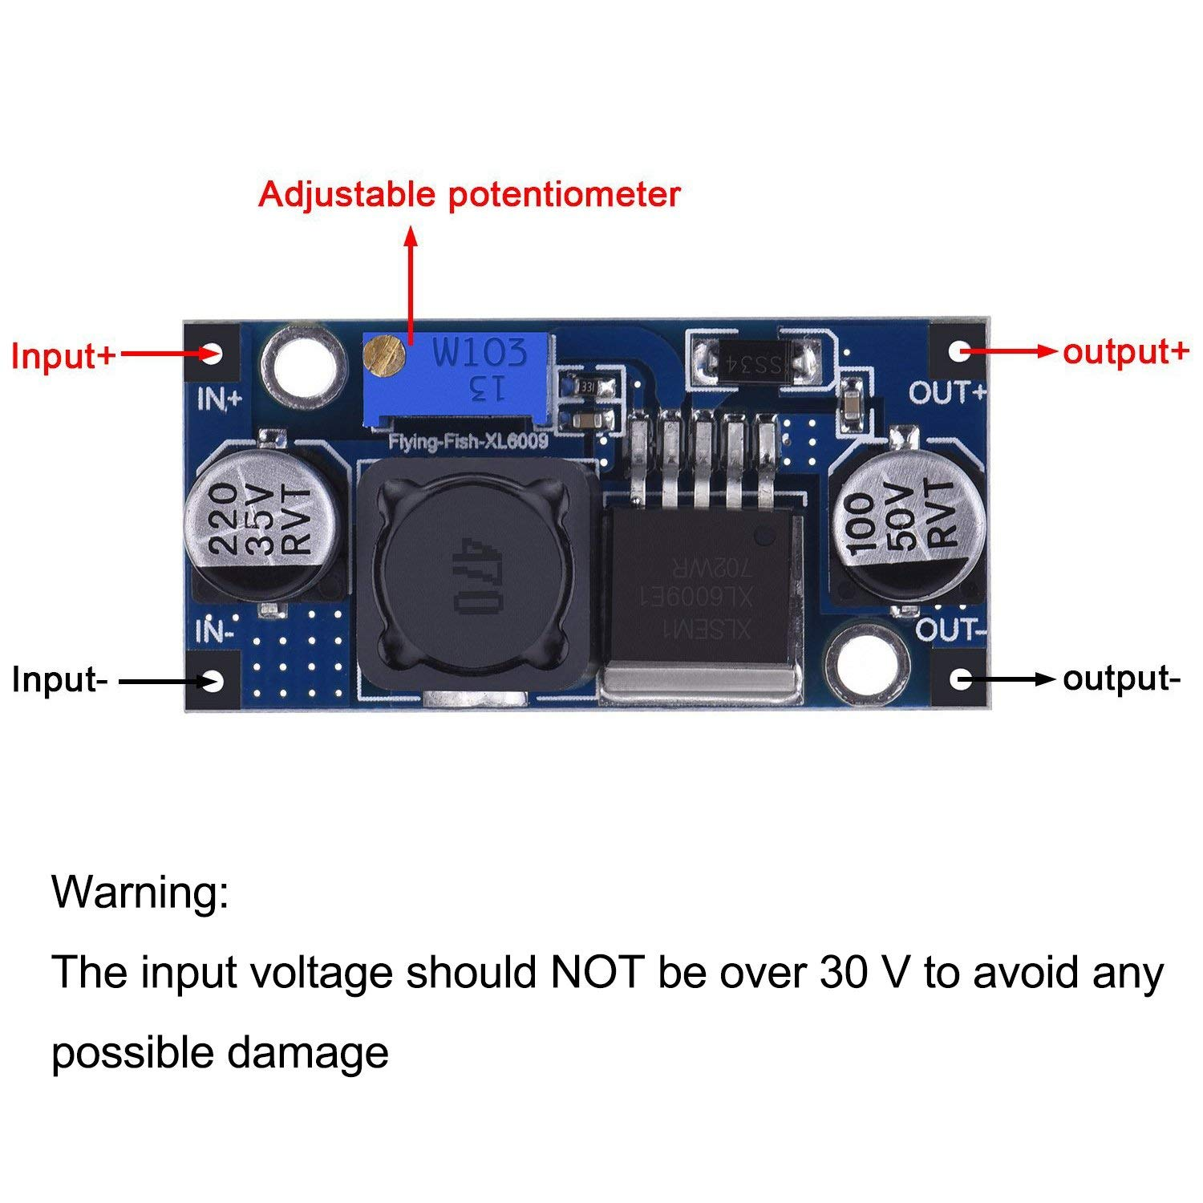

**Figure 14:** XL6009E1 40V boost converter [9]. This boost converter board has XL6009E1 chip attached and can convert input of two 9V batteries (18V) and output 40V.

The design of this boost converter was then successfully reverse engineered by following the datasheet of the switching chip and the traces on the PCB of the product we bought that contained the xl6009e1 chip. We selected components based on the datasheet, however we also included an additional schottky diode footprint based on the smd component on the boards we bought. The components on the PCB we made containing the boost converter can actually handle voltages up to 60V which is higher than that of the bought boost converter, this is due to the fact that we specifically chose a schottky diode and inductor that can handle higher voltages at a lower current. Though the data sheet recommended the MBR560 diode, we noticed that the ss16 diode can handle the same voltage at a lower current, however because our application is low current, it is still within specification. The inductor used was also sized smaller because of the lower current demand of the circuit. The circuit schematic of the boost converter on our tDCS device is shown in Figure 15.

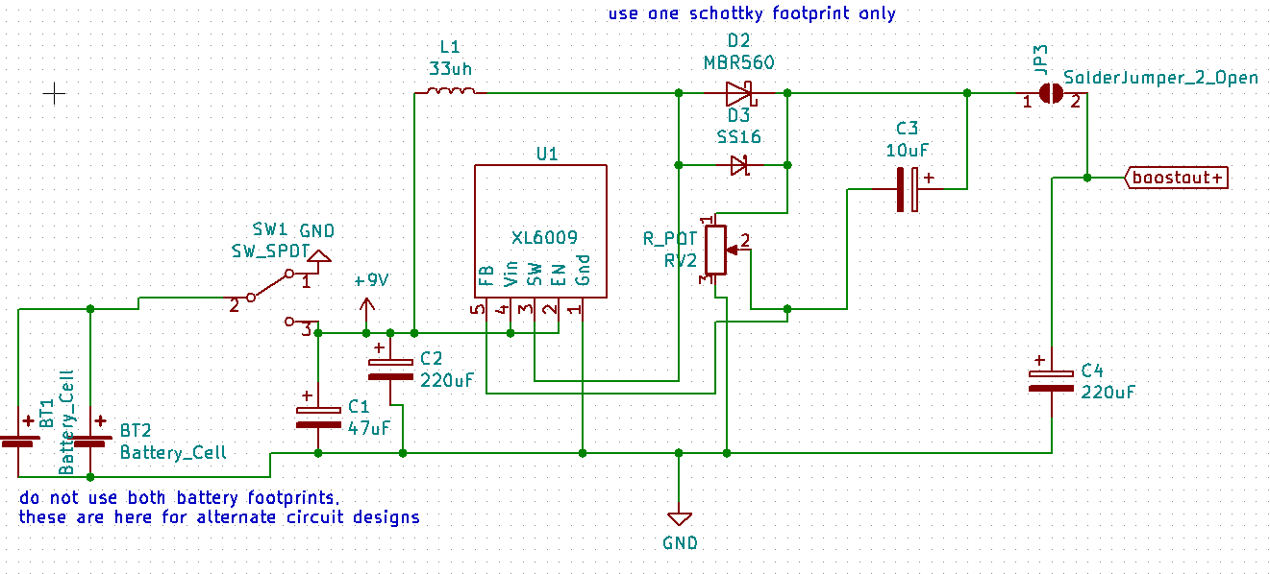

**Figure 15:** circuit schematic of the boost converter built on to the circuit PCB.

The next circuit challenge was to increase the reliability of our circuit. This was primarily accomplished by using NI Multisim simulation methods to replace potentiometer components with a fixed resistors to provide 2mA without the option for the user to switch outputs.This is shown in Table 4 under the breadboard column. We also made progress on the actual medium our circuit was on. While in theory breadboards, protoboards and pcbs should function the same, in practice however, there is in fact a difference in terms of circuit stability and usability. Initially when we were working on just the constant current circuit, we used just a breadboard, however as we started adding more features such as the ramp microcontroller and safety mechanism we moved our circuit to proto-board which is shown in Table 4. This improves the stability of the circuit and decreases the chance of human error. Other changes we implemented to the constant current circuit was to change some of the resistor values to withstand higher currents without increasing the resistor rating. This made parts sourcing difficult and slightly more expensive.

|  |  |  |
| --- | --- | --- |
| Breadboard | Protoboard | PCB + ext. Micro controller |
|  |  |  |
|  |  |  |

**Table 4:** This table shows how our circuit changed and how it looked when the circuit was on breadboard, Protoboard , and PCB.

**Ramp design**

We designed our ramp by using the transient state in a N type MOSFET (Metal oxide field effect transistor) as a variable potentiometer which is controlled by a smoothed (low pass filtered) PWM signal shown in Figure 16. We had a challenge with low pass filtering this signal because of the high noise. Ultimately, we solved this by using a higher value capacitors to reduce ripple voltage. We also addressed the problem of the ramp not having enough steps in the 8 bit PWM mode. To do this we changed the clock used for PWM in the atmega328p in software which gave us a 16 bit PWM signal. In doing this we were able to have more than 5 steps in our ramp.

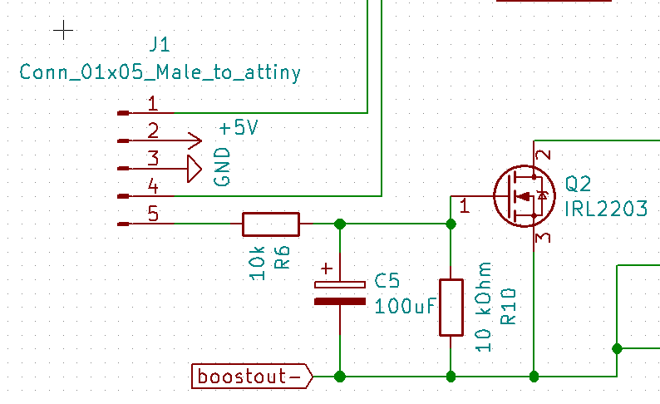

**Figure 16:** Ramp circuit with low pass filter. Also shown: the input of the ramp circuit

goes to pin 5 of a connector, which in turn goes into a pwm pin on the microcontroller.

In working with this version of the ramp circuit, we realized that there was a problem with the pulldown resistor (R10) on the base of the mosfet. This pulldown should actually be a pullup resistor, this was changed in a later version which is shown in Figure 17. The reason is that while the arduino is booting up the mosfet base pin will be pulled to ground which in turn will cause the constant current circuit to be at 2 mA as the arduino boots. Instead while the arduino boots, the base should be at 5v so that on boot the output current is at 0 mA.

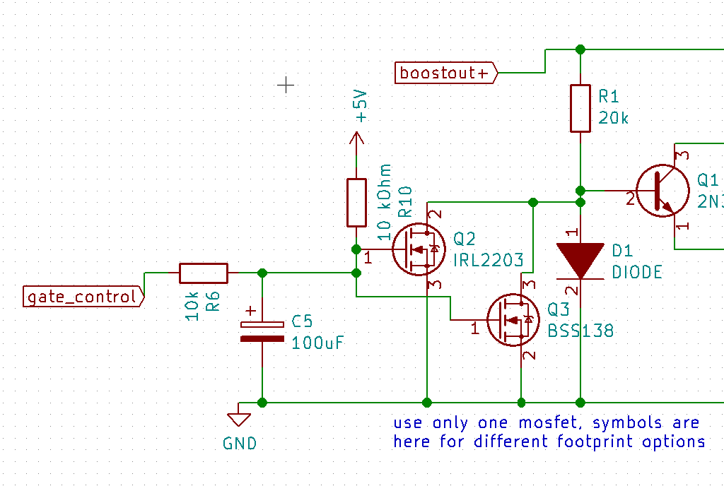

**Figure 17:** In a newer version of a PCB we changed a pulldown resistor to a pullup.

While this circuit for the ramp design is mostly functional, there are critical limitations to this design. The first limitation of using this design was found when trying to calibrate the device. We learned that relationship between the output of the arduino have the same relationship with the output of the constant current circuit. Instead we observed a phenomenon where the curve that relates digital output with the output signal is not the same between trials. Even trials conducted very close in terms of time. The curves are shifted in terms on the digital output axis. However, not in the current axis as shown in Figure 18 .

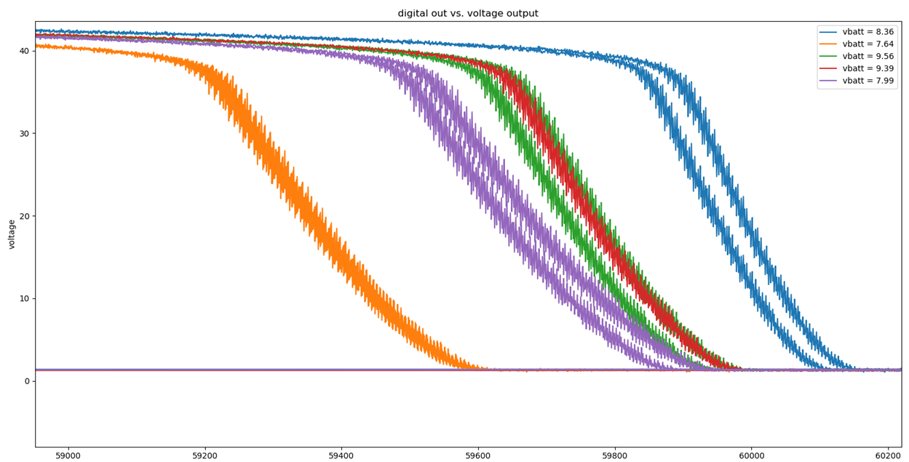

**Figure 18:** These curves were all performed under the same conditions (including a 20k load). However, to rule out changes in battery voltage we also recorded battery voltages when we measured the output voltage. The disparity here could be due to heat build up in a component or an unknown variable, it is not clear.

Despite this limitation we can still develop a safe ramp. This is because we can determine the greatest change in voltage with respect to digital output (dV/dD) based on our calibration. Additionally, based on our calibration we know that the overall curve shape is consistent despite the drift. If we have in mind a set change in voltage over time, we can then change the digital output in such a way that it can reliably prevent fast changes in voltage which can result in injury or discomfort. However, instead of having a linear or static change in the digital output to produce a ramp, perhaps a better approach would be to change digital output dynamically by incrementally increasing the digital output, and then reading the output voltage to measure whether it has increased enough. This could be implemented using the safety mechanism built in our circuit and the arduino which can read voltages and put into effect the control loop. However, we did not have enough time to do this but we did demonstrate that even without a control loop we can ramp the digital output to produce a ramp to our liking at the cost of stimulation start time precision.

We also worked on multiple revisions of a safety feature where the user will not be able to operate the device until the circuit detects an impedance across the output. This would prevent sudden onset of the output current even if the user turns on the hat before placing it on their head. With old current design which is shown in Figure 19, we can observe a signal between 1V and 5V which is inversely proportional to the output voltage of our tDCS. The output voltage is in turn directly related to the load resistance of the head. We can then use the microcontroller to measure this signal and have the circuit only start ramping if and only if there is infact a reasonable load in the cap.This plan was abandoned as it appeared to be unreliable in testing, the output of the safety circuit did not reflect changes of the output strongly.

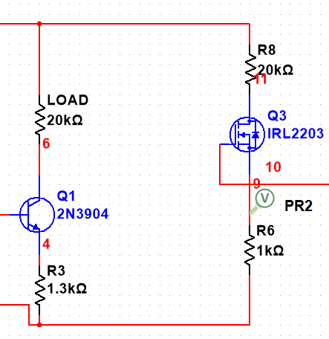

**Figure 19:** This shows the circuit schematic for headgear safety. On the right hand branch is the safety circuit, on the left is where our load is located. As the current through the left hand branch changes due to load, a corresponding and proportional change in voltage will be detected in the node labeled V.

Instead of using the mosfet based safety mechanism, ultimately we used a more simple system where we have high impedance, low tolerance (or calibrated) resistors to form a voltage divider between both electrode nodes and ground. The circuit schematic of the voltage divider is shown in Figure 20. The outputs of the voltage dividers are then subtracted from one another to find the differential voltage across the outputs. One caveat is that using the arduino’s ADC (analog to digital converter) we encountered noise issues, this was resolved using an IIR filter using 2nd order butterworth coefficients. However, this does means that it takes about 15 milliseconds for a filtered measurement to be taken, faster measurements can be taken at the cost of precision.

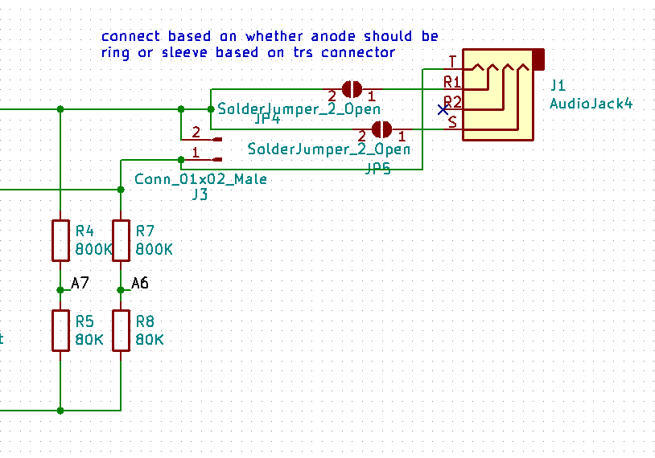

**Figure 20:** R4, R5, R7, R8 form voltage dividers between the electrodes and ground. The output of the voltage dividers (node between resistors R7 and R8 as well as resistors R4 and R5) are connected to the arduino nano on pins A7 and A6.

The voltage detection signals and the signal required for the ramp will be provided by an arduino nano. Originally we started prototyping on the arduino nano. Our plan was to move on to the ATTINY85-20 microcontroller. Unfortunately, the microcontroller had an issue where even though one of the pins were described as both input and output, it also served as a reset pin so there were technical issues that would not be solved within the semester. Instead, we are going to go with our backup plan to use atmega328P, the chip on the arduino nano. We already know that the arduino nano has the capability to produce the PWM signal to the mosfet “variable potentiometer,” and read the voltage output. The arduino nano is cheap, but in the future just the raw atmega328p chip can be used to make the overall PCB smaller.

The latest PCB version of the circuit does not work simply because of come troubleshooting issues and lack of time. However, the concept of the new design was to solve to resistor pull up issue and incorporate the arduino nano, buzzer and safety circuit in one unified PCB as opposed to two stacked boards. Even though the latest PCB version had problems we still needed a functional prototype which is the two stacked boards. The functional prototype is shown in Figure 21.

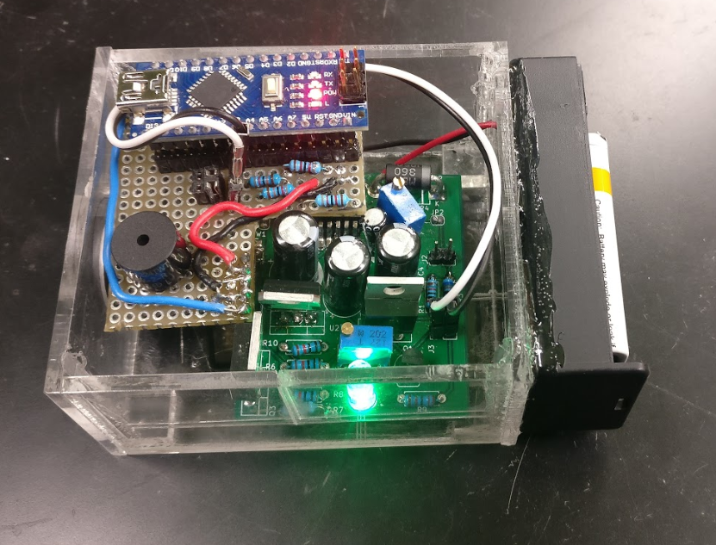

**Figure 21:** This shows the functional prototype of the device. The PCB was built with constant current and boost converter circuit but does not have the footprint to place arduino nano, the buzzer, and the safety circuit. However, the PCB did have pins to attach arduino nano externality. All the missing components were put together on a protoboard and was attached on top of the PCB to give us the functional prototype.

In the process of developing our circuit we took advantage of modern techniques simulation and manufacturing.Though we started with a rudimentary circuit with simulations using NI multisim, we were able to rapidly test and experiment with different designs to come up with the design we have now. This allowed us to Identify ways to modulate the constant current source to work over longer impedance ranges and at different current settings. We also took advantage of PCB manufacturing, thanks to our second order of components we were able to design and rush a design to pcbway (manufacturer specializing in PCB prototyping) which ended up being our functional prototype for the circuit.

**Headgear Process**

Our headgear was designed initially for the depression montage, however, we have moved to the concentration montage. The reason for the change in montages is because our circuit cannot accommodate a higher impedance value. This will be further explained later on in the circuit testing section. The headgear will use sponges with an inserted snap-carbon rubber electrode as seen in Figure 22. The carbon rubber insert helps distribute the current throughout the whole sponge. The headgear will also include a mounted circuit box so we will have to take the weight of the box into consideration to prevent the user from feeling any sort of discomfort.

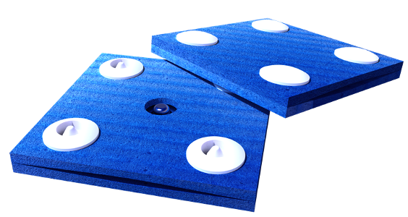

**Figure 22:** Sponge electrodes with a snap-carbon rubber electrode [12].

We found that the headgear design with the best ergonomics was the cap design, seen in Figure 23 below, with the two snap pins attached on the approximately measured positions, FP1 and FP2, which correlates to the concentration montage shown in Figure 24. The sponge electrodes will be snapped onto the two snap pins by the user. Using a hat we are able to keep the montage/electrode placement preset so a first time user would not get confused.

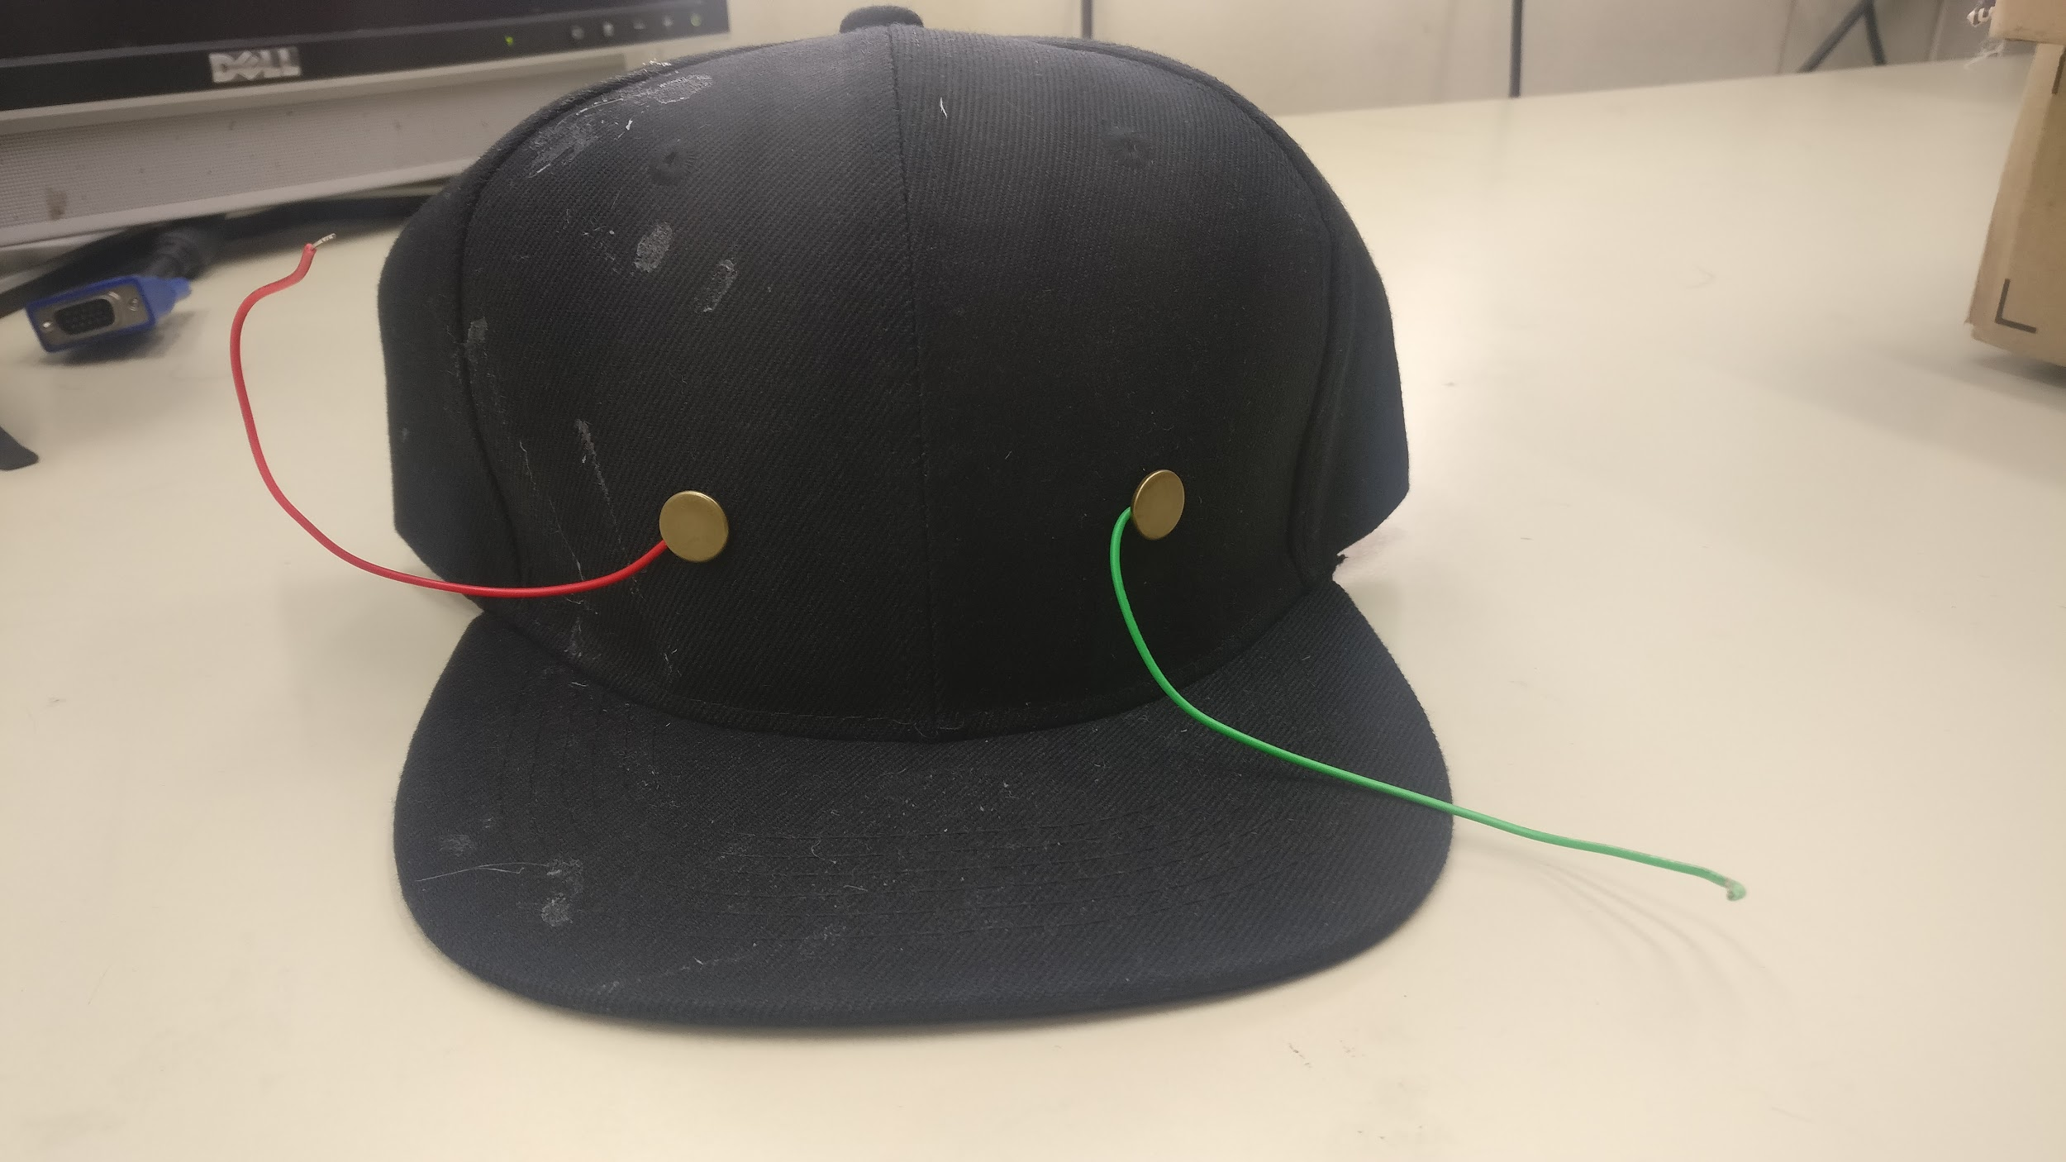

**Figure 23:** The cap design with two wires and two snap pins in the FP1 and FP2 position.

For the headgear one of the most important thing is to have a proper contact between the electrode and the head. The contact quality is based on the head impedance measurement. Good contact quality is within the range of 10kΩ-20kΩ, based on our circuit and we were able to achieve an impedance reading of around 21kΩ with our headgear. This measurement, however, varies with individuals with different skin types; dry skin, oily skin, thick skin, thin skin, or lotioned skin.



**Figure 24:** Montage FP1 and FP2 of the head for the concentration montage [11].

One of the problems we found was that extra saline was needed to be applied to the sponge, which comes pre moistened, to maintain the low impedance for a longer period of time and to decrease the impedance on the skin.

Another problem came up when we added extra saline on the sponge electrodes. We found out that the extra saline was seeping through the fabric of the hat, which is critical in the reading of the actual impedance because the amount of the saline that goes through the skin will be altered. Also, the two moistened areas can be connected and form a closed circuit which can affect the reading of the impedance. The moistened fabric will also cause current to flow through the hat instead of the electrodes which can interfere with the treatment. We came up with a solution of using a new hat with a thicker material so that it would take more saline than what we currently use to soak through the hat.

**Testing protocols:**

**For Circuit:**

The primary testing protocol for the circuit will first measuring output current with respect to the impedance of the head which will be simulated with just a resistor. We have conducted this test to both assess the outcome measure in terms of output current and range of resistances in which our device will work. The data collected are shown in graph in Figure 25 and Figure 26 based on the design built on perforated prototyping board and breadboard.

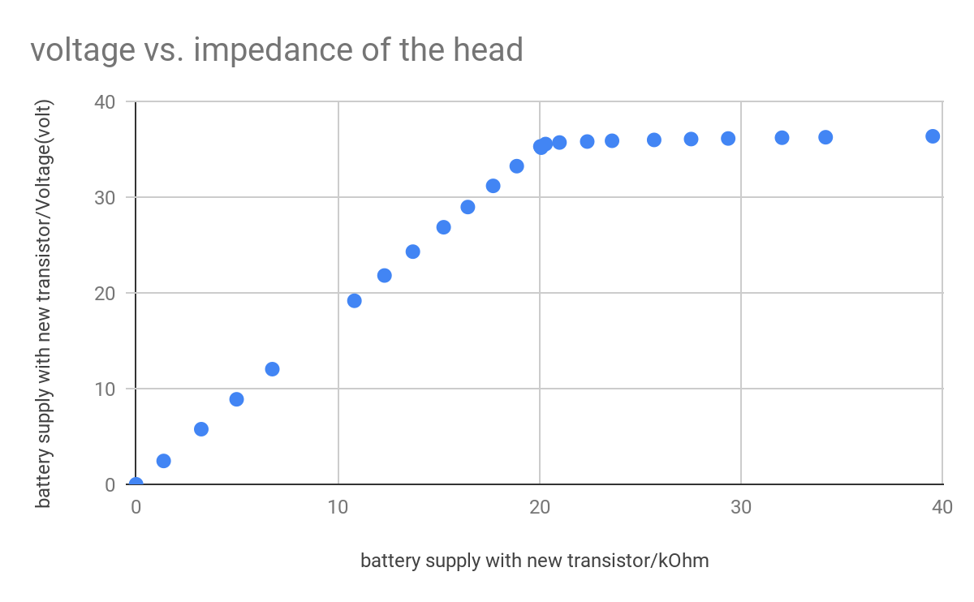

**Figure 25:** This graph of the circuit shows that the voltage increases up to resistance limit.

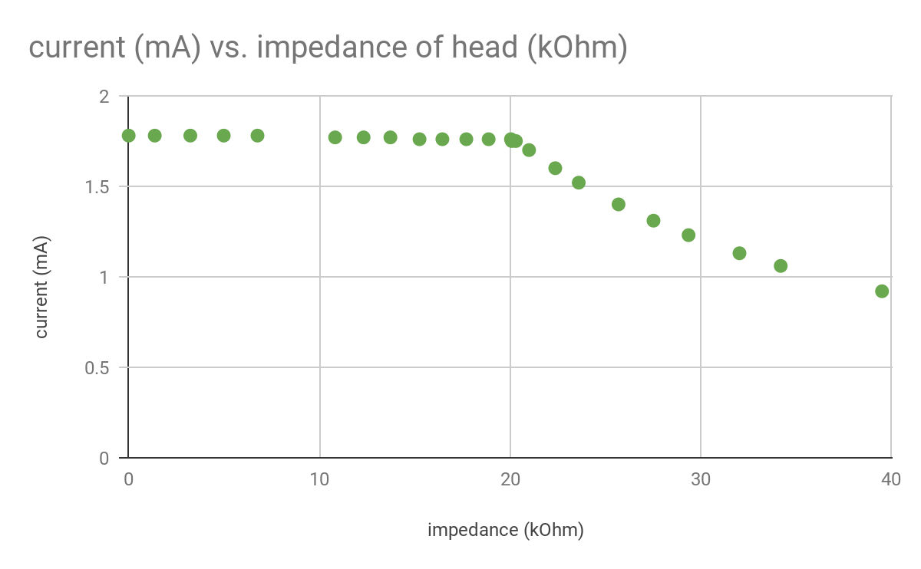

**Figure 26:** The current is constant until it hit a certain resistance limit (20kΩ).

Following this initial data collection, we also repeated this testing on our PCB design. We conducted a test of an example stimulation which is shown in Figure 27, and a test of the current with respect to load resistance which is shown in Figure 28, in addition to the testing needed for producing the calibration curves.

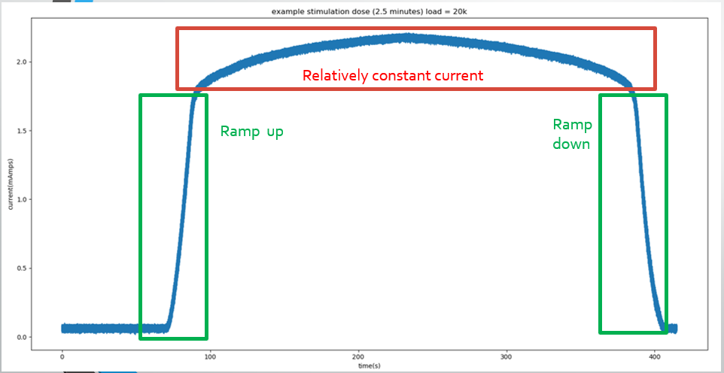**Figure 27:** This plot shows what a dose might look like, in this case we shortened the does to about 2 minutes with a short ramp up and ramp down. The data was taken with NI myDAQ, a portable data acquisition device used to capture the output data of the circuit over the time.

This test of visualizing the output signal showed us that the output was not exactly 2mA , and it did not have a completely flat look, however this bulge in the middle may have been due to one of the large capacitors charging and discharging.

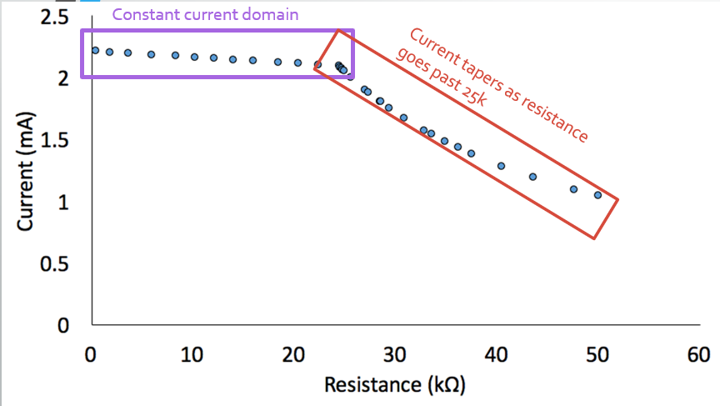

**Figure 28:** This test is a repeat of our previous tests conducted on the unintegrated design. Here we can see an increase in the range of resistances our circuit works on due to a slight change in the position of our potentiometer in the constant current circuit, as well as a the change of a more optimized boost converter. The graph shows the current supply over a 50kΩ impedance. Constant current of about 2mA is supplied over 0-25kΩ impedance (working range). The current drops gradually to 1mA afterwards. ​

**For Headgear:**

The testing protocols for the headgear we used are SUS (System Usability Scale) and Impedance Testing.

**SUS (System Usability Scale)**

The SUS test will allow us to gauge how easy it is to properly use the hat. The SUS test will have 10 questions with 5 response options numbered one to five. The test is scored by subtracting one from odd numbered user responses and subtracting five from even numbered responses [5]. All the numbers are then added and multiplied by 2.5 to convert the scale from 0 to 100. The average SUS score from 500 different studies is 68, so a value above 68 would be considered above average and a value below 68 would be considered below average [5].

To administer the SUS test we will provide the user with instructions on how to put on the hat but not interfere with the procedure. We will then measure the impedance to see if the user would be able to get an impedance, within our working range, without any assistance.

To determine the sample size that we need a research paper on specifying participant groups on usability testing, showed that a sample size of 20 is within 98.4% of the mean number of problems found, as seen in Figure 29 [6]. Figure 29 also shows that increasing the sample size from 5 to 10 greatly increases the number of problems found. Increasing the sample size from 10 to 15 and so on, however, shows that the number of problems found minimally increases. This shows that SUS doesn’t require a large sample size to yield analytical results. Based on the research paper, we decided to choose a sample size of 20 to safely have both the minimum and mean % found to be over 95%.

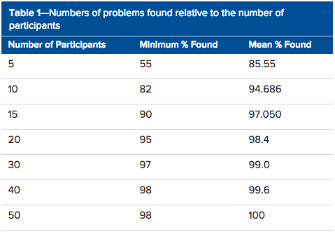

**Figure 29:** Shows the increase in participants past 15 has minimal effect on the number of problems found [6].



**Figure 30:** Shows the score of SUS from 20 different subjects.

The bars represent each subject SUS test results. For a pass the SUS average should be more than 68 and fails less than 68. The average of our SUS score is 76.7.This shows that the headgear is easy to use and easy to understand (user friendly).​

**Impedance Testing**

Another testing protocol we used was measuring the impedance of the hat on a user’s head over a period of time. We took measurements in 5 minute increments over a duration of 30 minutes, a standard dose for a tDCS treatment. This allowed us to see if the impedance would change over time and what the average impedance value was. As you can see in Figure 31, in all subjects impedance decreased over time. This can be due to the saline slowly saturating the skin to provide better contact. There was also an outlier with a measured impedance of 70kΩ and we found out the cause of this issue might be either dry skin or a thicker than normal skin type. The average impedance of all 20 subjects came out to be 20.3kΩ ± 3.54kΩ, which falls within our working range for our circuit.

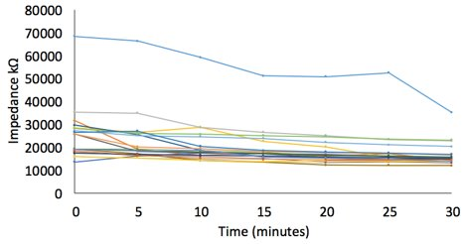

**Figure 31:** Shows the impedance value of 20 different subjects over time.

**Estimated BOM**

|  |  |  |  |
| --- | --- | --- | --- |
| Item | Bulk pricing estimate | Low quantity pricing (10 units) | Quantity |
| [hat](https://www.amazon.com/dp/B07B4MLNT9/ref=sspa_dk_detail_3?pd_rd_i=B07B4LGWK7&pd_rd_w=Z7MHU&pf_rd_p=f0dedbe2-13c8-4136-a746-4398ed93cf0f&pd_rd_wg=Rmk3w&pf_rd_r=JPQN2MECWP9F2ADT5NXJ&pd_rd_r=5ea10233-27fd-11e9-bd5b-dfbc5f26256b&th=1) | [$1.5 @ 1k](https://www.alibaba.com/product-detail/Wholesale-High-Quality-Custom-6-Panel_60738470944.html?spm=a2700.7724857.normalList.170.45157c15LOrMBB) | $3.33 | 1 |
| [saline 15 mL](https://www.amazon.com/Modudose-Unit-Dose-Saline-Box/dp/B00AQLMLZK) | $0.415 | $0.415 | 1 viral (15mL) |
| [Snap fastener kit](https://www.amazon.com/KINGSO-leather-buttons-decoration-Fasteners/dp/B076J89KD1/ref=mp_s_a_1_4?ie=UTF8&qid=1549594365&sr=8-4&pi=AC_SX236_SY340_FMwebp_QL65&keywords=kingso%20snap&dpPl=1&dpID=51XY%2B4UpAFL&ref=plSrch&fbclid=IwAR3ud0DIE_mZhq7Af3VHIJ4p4TS0megDOxP0BQRjotGgvohU2435XEDXTe4) | $0.38 | $0.19 | 4 |
| [Circuit box](https://www.amazon.com/uxcell-100mmx68mmx40mm-Universal-Enclosure-Transparent/dp/B0714N28YT/ref=pd_sbs_328_4/131-8655024-4037924?_encoding=UTF8&pd_rd_i=B0714N28YT&pd_rd_r=65cf72c8-4a94-11e9-b794-47d98422d647&pd_rd_w=HlT3w&pd_rd_wg=XpKVY&pf_rd_p=588939de-d3f8-42f1-a3d8-d556eae5797d&pf_rd_r=Q7F75X4Q1B993G50ZZCV&psc=1&refRID=Q7F75X4Q1B993G50ZZCV&fbclid=IwAR3gxEc7xG2Hhy-JS7J-QkjeZXY5gptpy2YawdbwwuIZNFMMo5srUX3pozw) | ~ $2 | $6.99 | 1 |
| [Strap](https://www.amazon.com/Bluecell-Black-Nylon-Heavy-Webbing/dp/B00KCC1H6C/ref=sr_1_6?keywords=strap&qid=1552930792&s=industrial&sr=1-6) | $0.603 | $0.603 | >1 yard |
| [Velcro](https://www.amazon.com/VELCRO-Brand-Industrial-Strength-Superior/dp/B0010HADEA/ref=sr_1_3?crid=1P1GDG6IZSPAP&keywords=velcro+strips+with+adhesive&qid=1553010527&s=gateway&sprefix=velcro%2Caps%2C161&sr=8-3) | $1.34 | $1.34 | 1 set |
| Sponge | $0.50 | $0.50 | 2 |
| [resistors](https://www.amazon.com/REXQualis-Resistor-Assortment-Kit-Values/dp/B07D54XMFK/ref=sr_1_2_sspa?ie=UTF8&qid=1546451385&sr=8-2-spons&keywords=resistor+kit&psc=1) | $0.0154 | $0.0154 | 10 |
| [220 uF cap.](https://www.mouser.com/ProductDetail/Panasonic/EEU-FS1K221?qs=sGAEpiMZZMsh%252B1woXyUXj3Q6FWM8D%252BEZmdJPa3tw%252Bjo%3D) | $0.284 @ 25k units | $0.601 | 2 |
| [100 uF cap.](https://www.mouser.com/ProductDetail/Panasonic/EEU-FS1K101L?qs=sGAEpiMZZMsh%252B1woXyUXj3Q6FWM8D%252BEZ60GocZgBueY%3D) | $0.17 @ 25k units | $0.39 | 1 |
| [10 uF cap.](https://www.mouser.com/ProductDetail/Nichicon/UPJ1K100MED1TD?qs=sGAEpiMZZMsh%252B1woXyUXjyKa7kR1qi6N%2FCBwmGzf1UU%3D) | $0.079 @4k units | $0.231 | 1 |
| [MOSFETs (N channel)](https://www.mouser.com/ProductDetail/Infineon-Technologies/IRL2203NPBF?qs=%2Fha2pyFaduj916qBev3m3VRN03mAn%2Ffz5wjcjK7eDUAk8vB3JhbJFQ%3D%3D) | $0.655 @ 1k units | $1.22 | 2 |
| [Npn BJT (2N3904)](https://www.mouser.com/ProductDetail/Central-Semiconductor/2N3904?qs=sGAEpiMZZMutncetXCRkfoW1QkrbVyPn) | $0.075 @25k units | $0.0445 | 1 |
| [5V regulator](https://www.mouser.com/ProductDetail/Texas-Instruments/LM7805SX-NOPB?qs=sGAEpiMZZMuKfYsiLTIqmBfgvtBJBVWLvyzCrlylmP0%3D) | $0.652 @ 10k units | $0.41 | 1 |
| [Shottkey diode](https://www.digikey.com/product-detail/en/on-semiconductor/MBR360RLG/MBR360RLGOSCT-ND/822814) | $0.1224 @ 500 units | $0.49 | 1 |
| l[ed](https://www.amazon.com/Projects-B-0001-C08-Clear-Green-LEDs/dp/B00GDALHZS/ref=sr_1_1_sspa?keywords=led&qid=1553397098&s=industrial&sr=1-1-spons&psc=1) | $0.07 | $0.07 | 1 |
| [inductor](https://www.digikey.com/product-detail/en/bourns-inc/SRN6045-330M/SRN6045-330MCT-ND/2756167) | $0.29670 @500 units | $0.49 | 1 |
| [buzzer](https://www.digikey.com/product-detail/en/pui-audio-inc/AT-1224-TWT-5V-2-R/668-1470-ND/5011404) | $0.25600 @ 5k units | $0.478 | 1 |
| Arduino nano | $1.14331 @6k units (atmega bare chip) | $1.58 (aliexpress price) | 1 |
| PCB | $.50 per board not rushed, and not including shipping | $0.50 (JLCPCB.com) | 1 |
| Total Price | $11.06 (nano design, no attiny) | $19.89 | 1 |

Table 5: Bill of materials of the device separated into two sections, the circuit and the headgear.

This is the total bill of materials (BOM) for the tDCS hat device (the headgear plus the circuit). The Table 5 is divided into three section Bulk pricing estimate, Low quantity pricing, and Quantity. The bulk pricing estimate is the price of the components if they were bought in bulk such as in units of 4k,10k,25k, etc. As it shows in the BOM table the price of the components are much cheaper when bought in large units. If this device were to be mass produced in factory then it would cost much less than making the device by buying singular components. The bulk pricing for the circuit components is $4.32 and the bulk pricing for the headgear is $6.74. Thus, the total bulk pricing for the device is $11.06 .

The low quantity pricing is our actual price for the device given $600 budget. The components were bought in units of 10 and the price for the components is shown in the BOM table. The low quantity pricing for the circuit components is $6.52 and the low quantity pricing for the headgear is $13.37. The total price of the both headgear and circuit combine is $19.89 which is 11 cents lower than what was stated in our project design specification. However, we could have made the price as low as $12.89 if we made our own box and not order premade off the shelf box. At high quantity our device is even cheaper, the total comes out to $11.06 which is almost 9 dollars lower than our design specification.

**Final Device:**

Our final device is significantly different from our mockup design. In our final device we used the concentration montage inside instead of the depression montage used in our mockup. We can use sponge electrodes from Soterix or handmade sponges in the interchangeable snap positions. The circuit that we used with the hat and all our testing is the first version of the PCB because we encountered unknown issues with the second version of the PCB. The newest version of the PCB was designed for the circuit enclosure that fits on the brim on the hat as seen in Figure 32.

|  |  |
| --- | --- |
|  |  |

**Figure 32:** Final device design with mounted circuit box (left) and separate functional circuit on the first version of the PCB (right).

This device satisfies what we see as a hole in the market for a simplified, user friendly and safe tDCS. Our device will give users, unfamiliar with tDCS, a chance to try out the treatment without having to spend a lot of money.

**Appendix**

<https://drive.google.com/drive/folders/1VBH5KhliZ7b90-iEWQBCHRFMXINIG0Ng?usp=sharing>

The link above in the link to our google drive where we documented everything since BME 450. All the necessary picture, videos, coding, reports, minutes are in drive.

**Instruction on how to wear the headgear**

1. Unpack two sponge electrode which is pre-soaked with the saline.

2. Snap both of the sponge electrode to the inner side of the headgear.

3. Adjust the sponges to fit on the outline on the inner side of the headgear.

4. Put on the headgear on your head and tightly adjust the rear snaps and the straps on the sides.

**SUS will consist questions:**

1. I think that I would like to use this system frequently.

Strongly Disagree Strongly Agree

|  |  |  |  |  |
| --- | --- | --- | --- | --- |
|  |  |  |  |  |

1 2 3 4 5

1. I found the system unnecessarily complex.

Strongly Disagree Strongly Agree

|  |  |  |  |  |
| --- | --- | --- | --- | --- |
|  |  |  |  |  |

1 2 3 4 5

1. I thought the system was easy to use.

Strongly Disagree Strongly Agree

|  |  |  |  |  |
| --- | --- | --- | --- | --- |
|  |  |  |  |  |

1 2 3 4 5

1. I think that I would need the support of a technical person to be able to use this system.

Strongly Disagree Strongly Agree

|  |  |  |  |  |
| --- | --- | --- | --- | --- |
|  |  |  |  |  |

1 2 3 4 5

1. I found the various functions in this system were well integrated.

Strongly Disagree Strongly Agree

|  |  |  |  |  |
| --- | --- | --- | --- | --- |
|  |  |  |  |  |

1 2 3 4 5

1. I thought there was too much inconsistency in this system.

Strongly Disagree Strongly Agree

|  |  |  |  |  |
| --- | --- | --- | --- | --- |
|  |  |  |  |  |

1 2 3 4 5

1. I would imagine that most people would learn to use this system very quickly.

Strongly Disagree Strongly Agree

|  |  |  |  |  |
| --- | --- | --- | --- | --- |
|  |  |  |  |  |

1 2 3 4 5

1. I found the system very cumbersome to use.

Strongly Disagree Strongly Agree

|  |  |  |  |  |
| --- | --- | --- | --- | --- |
|  |  |  |  |  |

1 2 3 4 5

1. I felt very confident using the system.

Strongly Disagree Strongly Agree

|  |  |  |  |  |
| --- | --- | --- | --- | --- |
|  |  |  |  |  |

1 2 3 4 5

1. I needed to learn a lot of things before I could get going with this system.

Strongly Disagree Strongly Agree

|  |  |  |  |  |
| --- | --- | --- | --- | --- |
|  |  |  |  |  |

1 2 3 4 5

|  |  |
| --- | --- |
|  |  |

**Figure 33:** Full device schematic of latest version with image of latest version of PCB

|  |  |
| --- | --- |
|  |  |

**Figure 34:** The older version of the circuit. Also the functional prototype.

**Device code:** Arduino nano that controls the ramp up and ramp down and also the safety circuit. Comments are provided in the code after “ ;// ”

/*

*/

/* Configure digital pins 9 and 10 as 16-bit PWM outputs. */

void setupPWM16() {

DDRB |= _BV(PB1) | _BV(PB2); /* set pins as outputs */

TCCR1A = _BV(COM1A1) | _BV(COM1B1) /* non-inverting PWM */

| _BV(WGM11); /* mode 14: fast PWM, TOP=ICR1 */

TCCR1B = _BV(WGM13) | _BV(WGM12)

| _BV(CS10); /* no prescaling */

ICR1 = 0xffff; /* TOP counter value */

Serial.begin(115200);

}

/* 16-bit version of analogWrite(). Works only on pins 9 and 10. */

void analogWrite16(uint8_t pin, uint16_t val)

{

switch (pin) {

case 9: OCR1A = val; break;

case 10: OCR1B = val; break;

}

}

//declare variables for butterworth filter

double b[3] = {0.0201,0.0402,0.0201};

double a[3] = {1,-1.5610,0.6414};

double s = 0;

double n = 0;

double t = 0;

double in[3] = {0, 0, 0};

double out[3] = {0, 0, 0};

double y=0;

double x=0;

void setup() {

pinMode(9,INPUT_PULLUP);

setupPWM16();

pinMode(9,OUTPUT);

pinMode(7,OUTPUT);

//initial input and output array

in[0] = 0; // x(k)

in[1] = 0; // x(k - 1)

in[2] = 0; // x(k - 2)

out[0] = 0; // y(k)

out[1] = 0; // y(k - 1)

out[2] = 0; // y(k - 2)

}

static uint16_t level = 0xffff;// set output to 0 mA initially

static uint16_t ilevel = 57000;// corresponding to 2 mA

static uint16_t maxlevel = 64000;//corresponds to 0 mA

static uint16_t tstep = maxlevel - ilevel;

double vplus, vminus, vout;

//variables for voltage divider calculation

double R1A = 80.9e3;

double R2A =.837e6;

double R1B = 80.2e3;

double R2B = .818e6;

double sum = 0;

double latest_voltage = 0;

bool chk_volt(){

sum = 0;

for(int m=0;m<3;m++){

vplus = ((R1A +R2A)/R1A)*analogRead(A7)*(0.0048875855327468);

vminus = ((R1B +R2B)/R1B)*analogRead(A6)*(0.0048875855327468);

vout = vplus - vminus;

x = vout;

//Update output x(k),x(k-1),x(k-2)

in[2] = in[1];

in[1] = in[0];

in[0] = x;

//Update output y(k-1),y(k-2)and Calculate the Filter signal output y(k)

//a(0)y(k)=b(0)x(k)+b(1)x(k-1)+b(2)x(k-2)-a(1)y(k-1)-a(2)y(k-2);

out[2] = out[1];

out[1] = out[0];

out[0] = b[0] * in[0] + b[1] * in[1] + b[2] * in[2] - a[1] * out[1] - a[2] * out[2];

out[0] = out[0] / a[0];

y = out[0];

delay(5);

}

latest_voltage = y;

if (latest_voltage < 53){

Serial.print("voltage check passed ");

Serial.print(latest_voltage);

return true;

}else{

return false;

}

}

void rampstart(int duration){

level = maxlevel;

analogWrite16(9,level);

while(level > ilevel){

level--;

analogWrite16(9,level);

delay((1000*duration)/tstep);

Serial.print(level);

Serial.print("\n");

}

}

bool stimfail = false;

void stimulation(int seconds){

level = 0;

analogWrite16(9,level);

for(int s; s < seconds; s++){

delay(1000);

if(chk_volt()){

Serial.print("passing second :");

Serial.println((s+1));

}else{

Serial.print("stimulation fail at ");

Serial.println(s+1);

tone(13,440,500);

delay(500 + 150);

tone(13,349,500);

delay(500 + 150);

tone(13,349,500);

stimfail = true;

}

}

}

void rampend(int duration){

level = ilevel;

analogWrite16(9,level);

while(level< maxlevel){

level++;

analogWrite16(9,level);

delay((1000*duration)/tstep);

Serial.print(y);

Serial.print(",");

Serial.print(level);

Serial.print("\n");

}

tone(13,440,500);

delay(500 + 150);

tone(13,349,500);

}

void loop() {

level = 0xffff;

analogWrite16(9,level);

if (!stimfail && chk_volt()){

Serial.println("beginning ramp");

rampstart(60);//ramp argument is duration of ramp in seconds

Serial.println("ending ramp,beginning stimulation");

stimulation(2*60);//simulation argument in seconds

Serial.print("ending stimulation");

rampend(60);

Serial.print("end ramp complete stimulation over, restart to begin stimulation again");

stimfail = true;

}

}

**References**

1. Brunoni AR, Nitsche MA, Bolognini N, et al. Clinical research with transcranial direct current stimulation (tDCS): challenges and future directions. *Brain Stimul*. 2011;5(3):175-195.
2. Thair H, Holloway AL, Newport R and Smith doi: 10.3389/fnins.2017.00641
3. Neyzi O, Bundak R, Gökçay G, et al. *nical Research in Pediatric Endocrinology*. 2015;7(4):280-293. doi:10.4274/jcrpe.2183.
4. DIY | DIY Tdcs | Page 2." Diytdcs.com. N. p., 2015. Web. 15 Oct. 2018.
5. “Measuring Usability with the System Usability Scale (SUS).” MeasuringU, measuringu.com/sus/.
6. “How to Determine the Right Number of Participants for Usability Studies.” UXmatters, www.uxmatters.com/mt/archives/2016/01/how-to-determine-the-right-number-of-participants-for-usability-studies.php.
7. <https://www.aliexpress.com/item/5pcs-MT3608-DC-DC-Step-Up-Power-Apply-Module-Booster-Power-Module-MAX-output-28V-2A/32517710689.html?spm=a2g0s.9042311.0.0.9fdf4c4dpYDM26>
8. <https://www.aliexpress.com/item/DC-DC-4-5-32V-to-5V-52V-XL6009-Boost-Step-up-Module-Power-Supply-LED/2036624928.html?spm=a2g0s.9042311.0.0.9fdf4c4dpYDM26>
9. <https://www.amazon.com/eBoot-Converter-Voltage-Adjustable-Step-up/dp/B06XWSV89D/ref=sr_1_1?keywords=xl6009E1&qid=1552787011&s=gateway&sr=8-1>
10. [**https://www.amazon.com/KIMME-XL6009E1-XL6009-Step-up-263-5L/dp/B07MLSJLXH/ref=sr_1_2?keywords=xl6009e1&qid=1552787078&s=industrial&sr=1-2**](https://www.amazon.com/KIMME-XL6009E1-XL6009-Step-up-263-5L/dp/B07MLSJLXH/ref=sr_1_2?keywords=xl6009e1&qid=1552787078&s=industrial&sr=1-2)
11. “TDCS Electrode Placement Montage Guide - Total TDCS.” *Total TDCS Electrode Placement Montage Guide*, totaltdcs.com.
12. <https://soterixmedical.com/research/1x1/accessories/snappad>
13. “What Is TDCS - Learn About Neurostimulation.” The Brain Stimulator TDCS Devices. Retrieved May. 16. 2019, from thebrainstimulator.net/what-is-tdcs/.----5
14. "The Brain Stimulator - Cranial Stimulation Devices." *The Brain Stimulator tDCS Devices*. N. p., 2018. Web. 16 Oct. 2018.
15. Mohammadi* A. Induction of Neuroplasticity by Transcranial Direct Current Stimulation . *Journal of Biomedical Physics & Engineering*. 2016;6(4):205-208.